Project Design Phase-II
Technology Stack (Architecture & Stack)

Date | 30 September 2026
Team ID | SWTID-2026-6606
Project Name | AI FitTrack API
Maximum Marks | 4 Marks

Technical Architecture:
The Deliverable shall include the architectural diagram as below and the information as per the table1 & table 2
Example: Order processing during pandemics for offline mode
Reference: https://developer.ibm.com/patterns/ai-powered-backend-system-for-order-processing-during-pandemics/
Guidelines:
Include all the processes (As an application logic / Technology Block)
Provide infrastructural demarcation (Local / Cloud)
Indicate external interfaces (third party API’s etc.)
Indicate Data Storage components / services
Indicate interface to machine learning models (if applicable)

Technical architecture of AI FitTrack API:
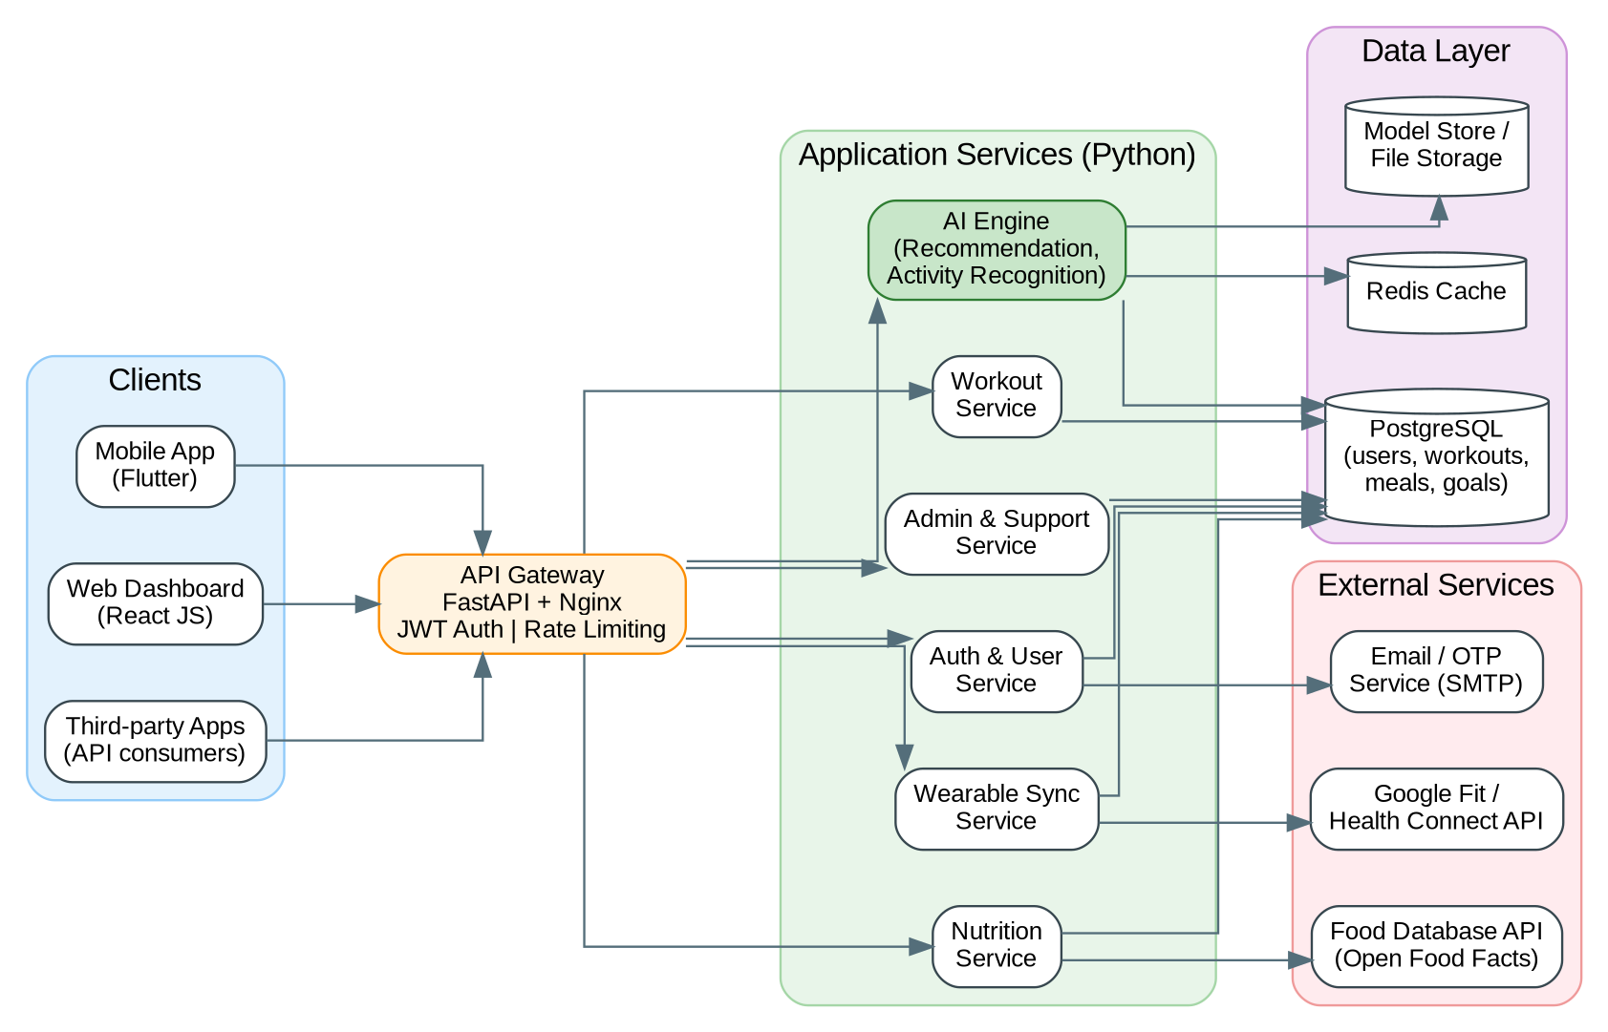

Table-1 : Components & Technologies:
S.No | Component | Description | Technology
 | User Interface | Web dashboard for users, administrators and care executives, and a mobile app to log workouts and meals and view plans | HTML, CSS, JavaScript, React JS (web); Flutter (mobile)
 | Application Logic-1 | Core REST API: registration, login, profile, workout and nutrition logging, and progress analytics | Python 3.11, FastAPI, SQLAlchemy
 | Application Logic-2 | Authentication and security logic: JWT tokens, Google sign-in, email confirmation and OTP | OAuth 2.0 / JWT, Google Identity, SMTP email service
 | Application Logic-3 | Background jobs: periodic wearable sync, reminders and notifications | Celery with Redis, Google Fit REST client
 | Database | Relational database for users, workouts, meals, goals and support tickets | PostgreSQL
 | Cloud Database | Managed database service on the cloud with automated backups and read replicas | AWS RDS for PostgreSQL
 | File Storage | Storage for trained ML models and exported reports | AWS S3 or local file system
 | External API-1 | Reads steps and heart-rate data from the user's wearable account | Google Fit / Health Connect API
 | External API-2 | Provides nutrition values for the food search | Open Food Facts API
 | Machine Learning Model | Recommends workout plans and calorie / macro targets, and recognises activities from sensor data | scikit-learn (Random Forest, regression), TensorFlow / Keras (1D CNN)
 | Infrastructure (Server / Cloud) | Application deployment on local system / cloud  Local Server Configuration: Python 3.11, Docker, 4-core CPU, 8 GB RAM  Cloud Server Configuration: AWS EC2 t3.medium (2 vCPU, 4 GB RAM) with RDS db.t3.micro | Local, Docker, AWS EC2 / RDS, Nginx

Table-2: Application Characteristics:
S.No | Characteristics | Description | Technology
 | Open-Source Frameworks | Open-source frameworks used: FastAPI, SQLAlchemy, Celery, React JS, Flutter, scikit-learn, TensorFlow, Pandas | FastAPI, React JS, Flutter, scikit-learn, TensorFlow
 | Security Implementations | Password hashing, encrypted HTTPS traffic, JWT / API-key access control, role-based access, input validation, rate limiting and firewall rules | bcrypt / SHA-256, TLS, JWT, IAM roles, OWASP Top 10
 | Scalable Architecture | Stateless, modular 3-tier architecture (client, API services, data layer). Containers can be added horizontally and the AI engine scales separately | Docker, modular services, PostgreSQL replicas
 | Availability | Several API containers behind a load balancer, health checks with automatic restart, and database backups and replicas | Nginx / AWS ALB, RDS Multi-AZ
 | Performance | Redis caching of dashboards and recommendations, asynchronous endpoints, database indexing and a CDN for web assets. Design target: 100 requests per second | Redis, async FastAPI, CDN (CloudFront)

References:
https://c4model.com/
https://developer.ibm.com/patterns/online-order-processing-system-during-pandemic/
https://www.ibm.com/cloud/architecture
https://aws.amazon.com/architecture
https://medium.com/the-internal-startup/how-to-draw-useful-technical-architecture-diagrams-2d20c9fda90d

